Important:
Change colors of headings in each section to black/ color used in h1
Add green color heading above main headings in each section
Font family of h1: Georgia, "Times New Roman", serif; 42px
Font family of main headings (h2): Georgia, "Times New Roman", serif; 32px
Font family of (h3):Georgia, "Times New Roman", serif;20px
Font family of green color headings/bold text: Inter, ui-sans-serif 13.7px
Font family of text: Inter, ui-sans-serif 16px

Hero section:
Not to change in our current takween connect website:

Header: do not make any changes in our current header

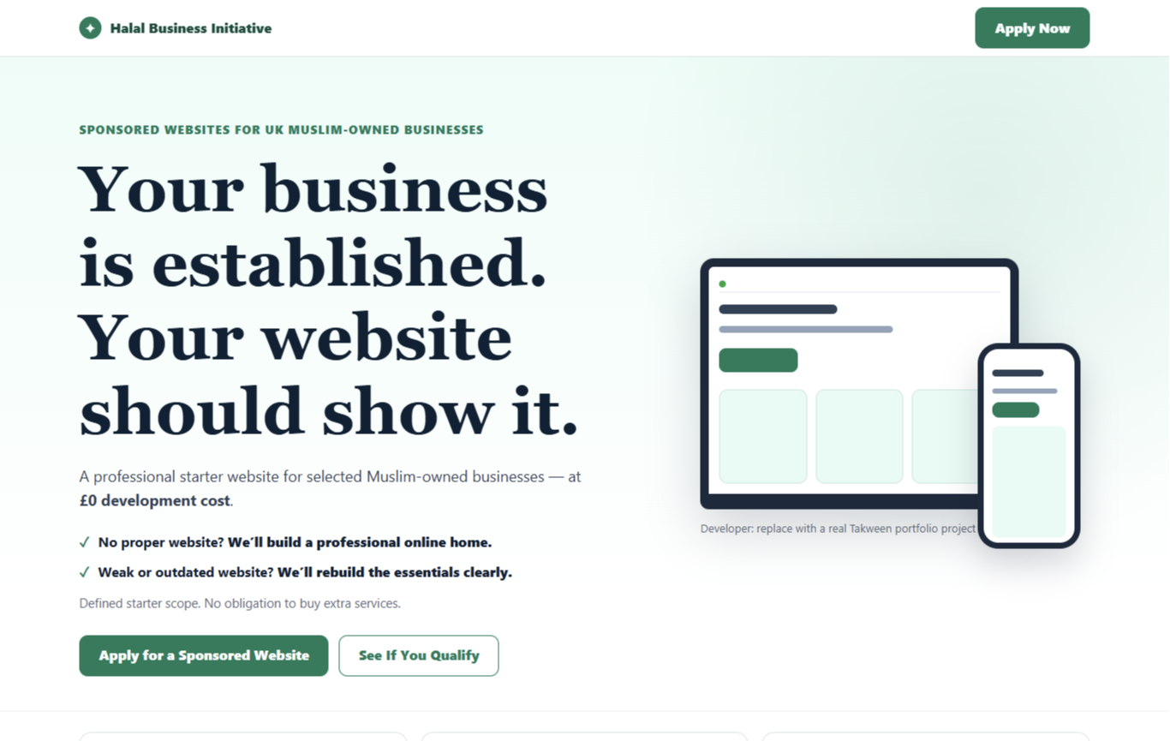

Section 2 – explain problem:

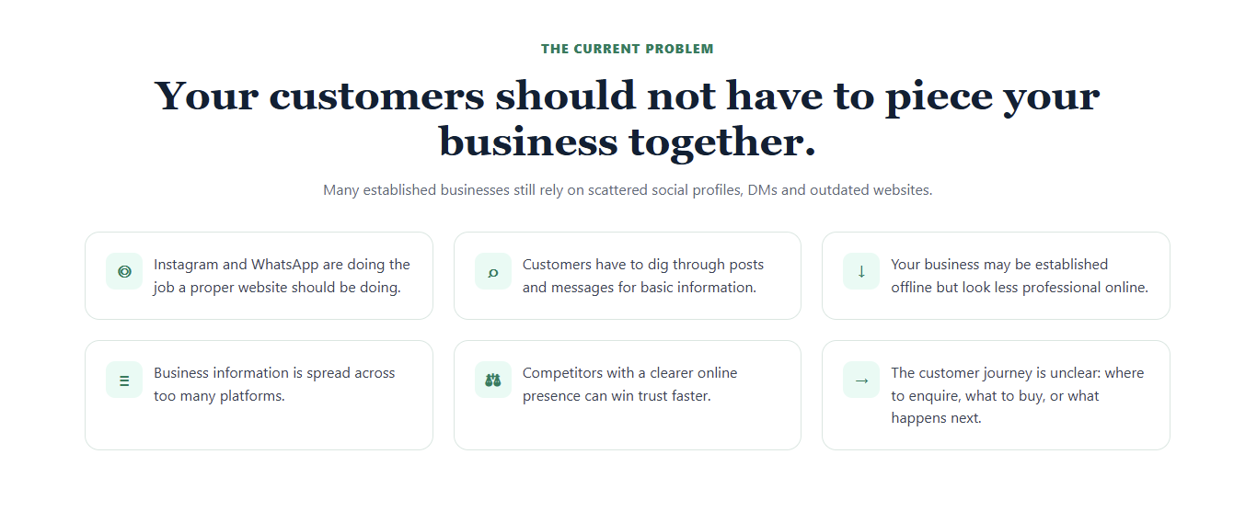

Section 3 –problem and its solution:
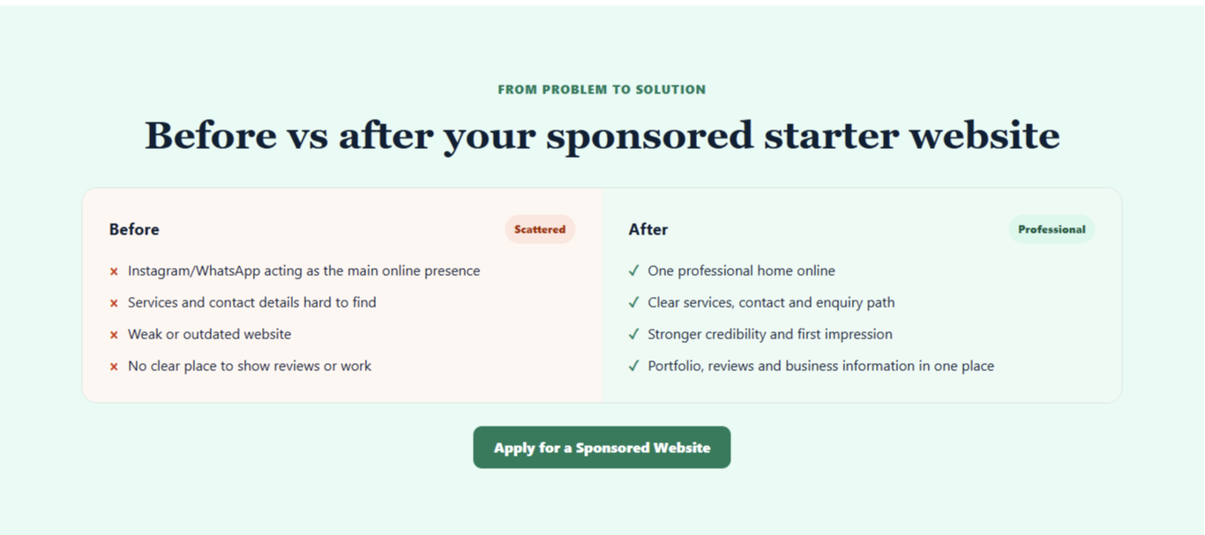
Section 4 – why it’s sponsored:

Changes to make in this content :
Replace the main heading “ why it’s sponsored” with
“ There is a clear reason why it cost you £0 to build”
Do not make any other changes in the layout, card, colors and icons on our current takween connect website
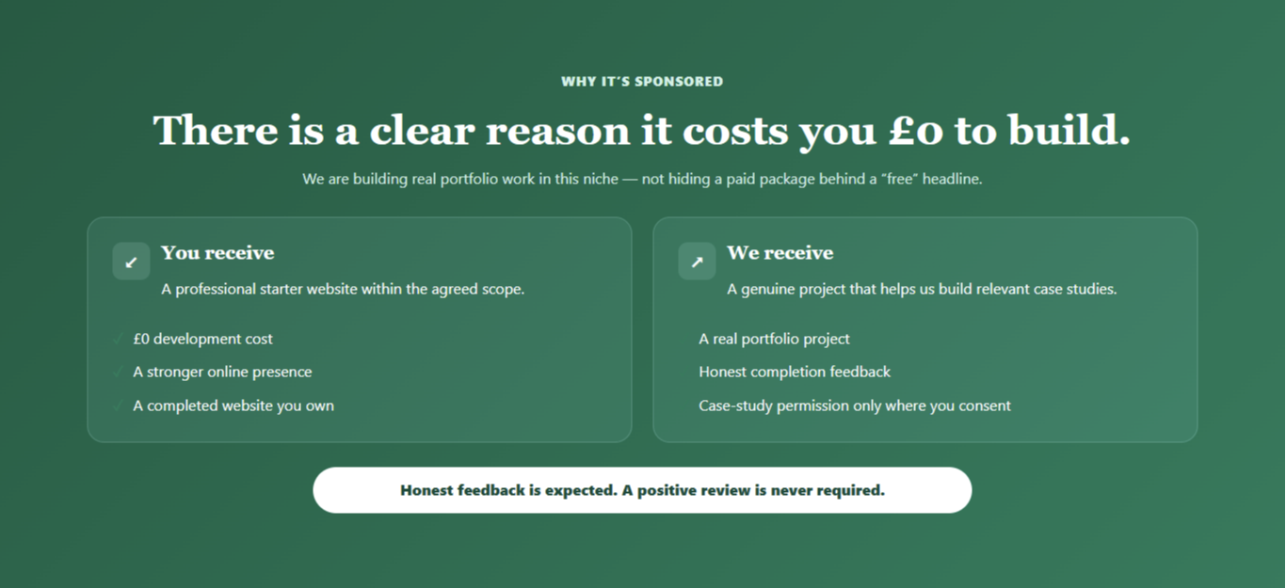

Section 5 –what do you get:

Changes to make in our current takween connect website:
Add “what you get” in green color
Replace “what’s in scope” to “clear free scope, clear free extra”
Add domain and hosting tab after cards (as shown in screenshot)
Add CTA button after domain and hosting tab (as shown in screenshot)
Do not change cards, colors and icons on our current takween connect website
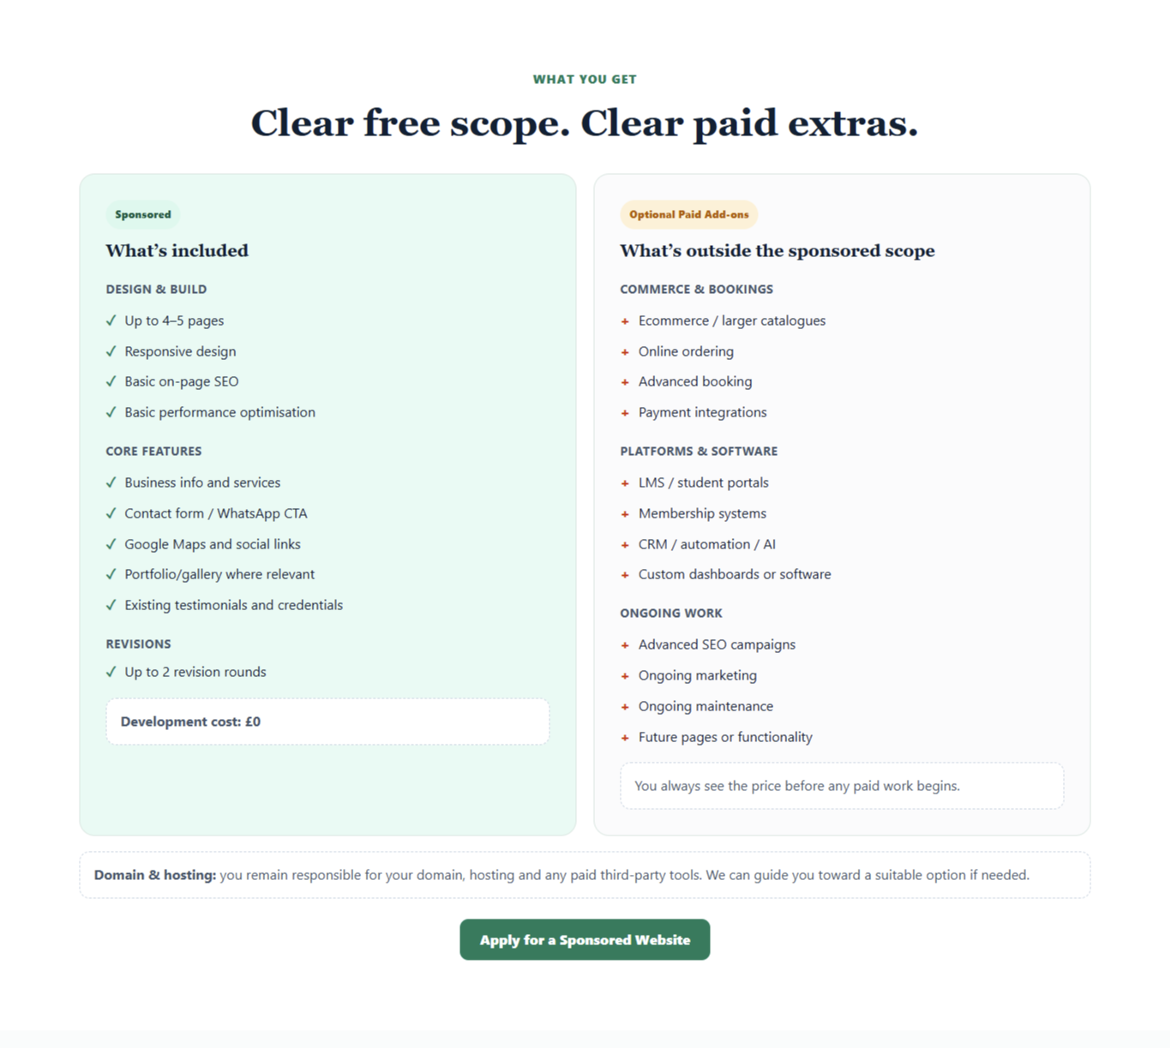

Section 6 – after launch,
Section 7 – who it’s for:

Change content as shown in screenshot
Add cta where it is shown in the screenshot
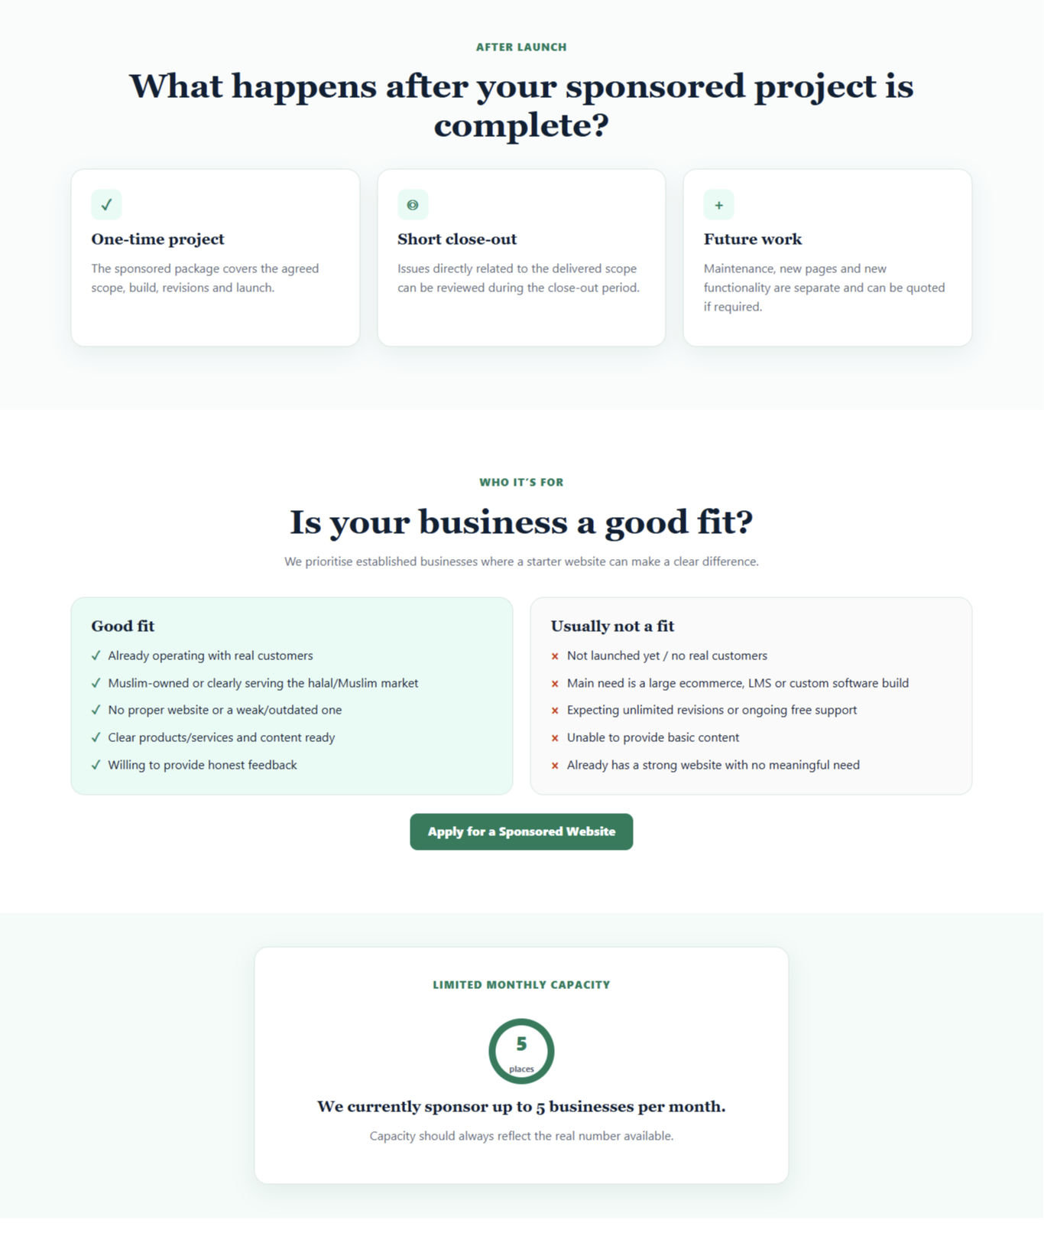

Section 8 – how it works:
Remove timelines from current cards on the website
Do not make any other changes
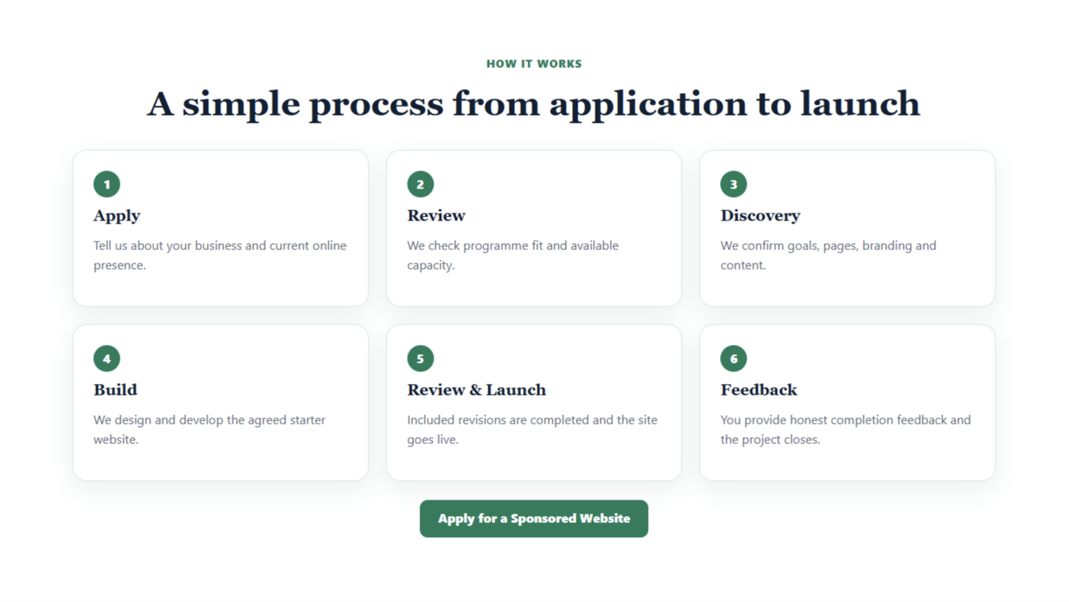

Section 9 – FAQ,
Section 10 – ready to apply
Section 11 – footer:

Change heading to your questions answered
Change text color of questions to black
Make “ready to apply section” as shown in the screenshot
Change footer as discussed in the meeting


